**ZATX Customer Inventory Management System**

* **PROJECT OVERVIEW**

In this project, a database system is created for company ZATX, a company that manages chemical storage terminals. Chemical companies use ZATX's tanks to store their products, and ZATX provides services for filling tanks and loading products onto trucks.

* **PROJECT SCOPE**

The primary objective of the project is to implement a MySQL relational database that will track customers, tanks, contracts and transactions and compute the necessary charges involved for the corresponding operation .

Implementation of Primary and Foreign Key relationships .

Usage of constraints like NOT NULL,AUTO_INCREMENT,CHECK.

Usage of Advance SQL concepts like Store Procedures and Trigger .

* **SYSTEM VIEW**

The database structure includes :

**MASTER TABLES : 4**

1. ci_company: Contains ZATX company Information
2. ci_tank : Contains Tank Information
3. ci_operation : Contains Types of Operations and their Charges details
4. ci_customer : Contains Customer Information

**TRANSACTION TABLES : 3**

1. ci_contract : Maintains contract details between ZATX and customers.
2. ci_tankfill : Maintains records of Tankfill Operations.
3. ci_truckload : Maintains records of Truck loading Operations

**LOG TABLE : 1**

1. ci_translog : Transaction log of all operations.

**BUSINESS LOGIC VIEW:**

The Business logic is implemented using STORE Procedures and TRIGGER

* Store Procedure (1) : Adds new contract
* Store Procedure (2) : Records Tank filling operation
* Store Procedure (3) : Records truck Arrival for loading(Stage 1)
* Store Procedure (4) : Complete truck loading process (Stage 2)
* Store Procedure (5): Calculate Operation and Rental Charges
* Trigger (1) : To update tank Balance and log Entry after chemical is filled from vessel onto the Tank
* Trigger (2) : To update tank Balance and log Entry After Update after the Truck Loading of chemical

Store Procedure 1 :

This Store Procedure is used to record new customer contract. After successful validation , If the tank is free and not contracted by any customer then a new contract can be created .

Store Procedure 2 :

This Store Procedure is used to record Tank filling from the vessel . After validations are successfully completed , record is inserted into TankFill Table . An AFTER-INSERT trigger is used to update the balance quantity of the master Tank Table for the corresponding Tank_ID and log entries in the Log table for the TANK fill operation .

Store Procedure 3:

This Store procedure is used to record the initial weight of the Truck in the Truckload Table after validations are successfully completed . Exit and Net weight will remain NULL

Store Procedure 4:

This Store Procedure is used to update exit and net weight of the truck into the Truckload table after the validations are successfully completed . An AFTER-UPDATE TRIGGER is called to update the balance quantity in the Tank Master Table. log entries in the Log table for the TRUCK LOAD operation.

Store Procedure 5:

This Store Procedure is used to calculate the Operationl and Rental Charges for the respective Customer .

**ER DIAGRAM**

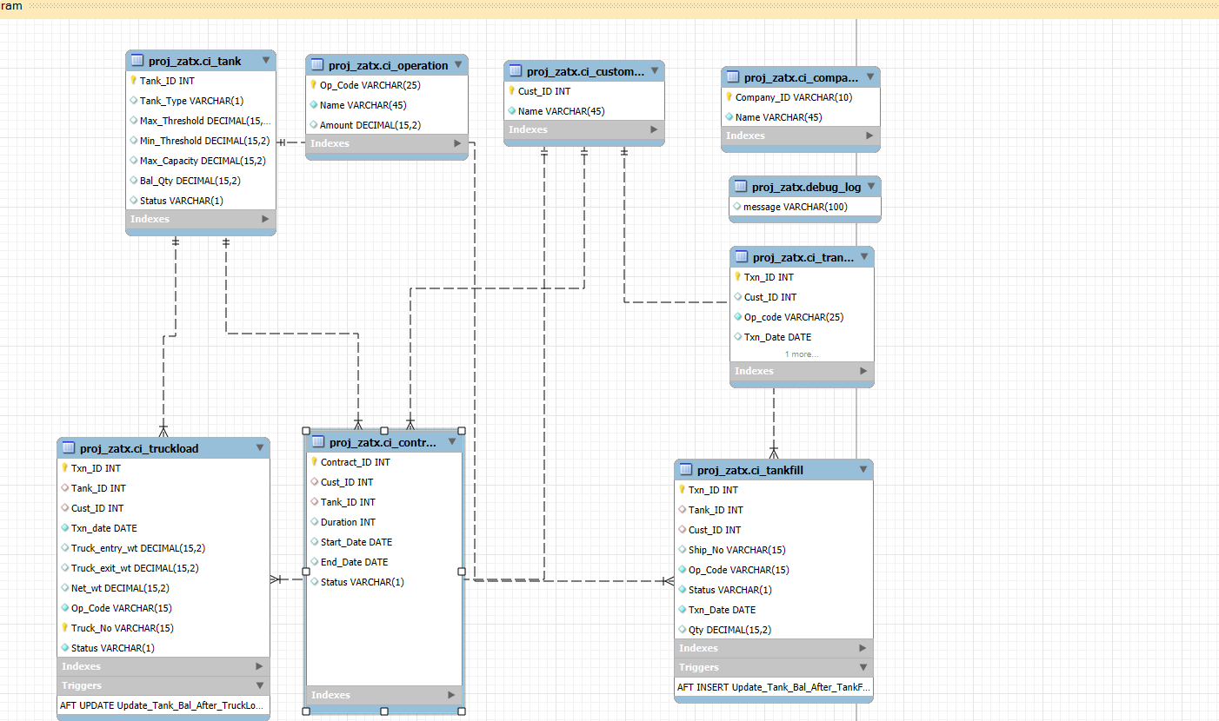

------- END -------------